

**Name : Ammaar Naeem Laghari**

**Roll No : 20P-0180**

**Section: BCS-5B**

**Course Name: Computer Networks LAB**

**Submitted to : Mam Hurmat Hidayat**

**Submitted on : 10/05/2022**

**LAB 06**

TASK 1:

Step 1:

Build a network topology.

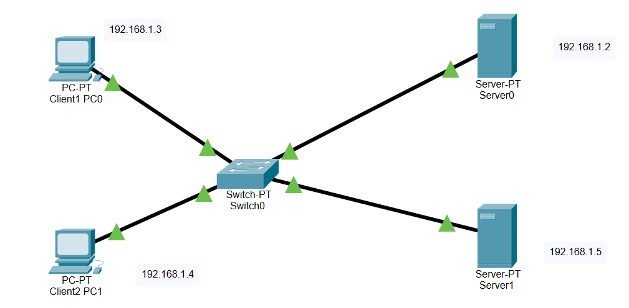

Step 2: Configure IP addresses on the PCs, DNS Server and the Mail Server.

• Mail Server IP address: 192.168.1.2

• PC0 IP address: 192.168.1.4

• PC1 IP address: 192.168.1.3

• DNS server IP address: 192.168.1.5

Step 3: Configure mail clients on the PCs and mail service on the generic server.

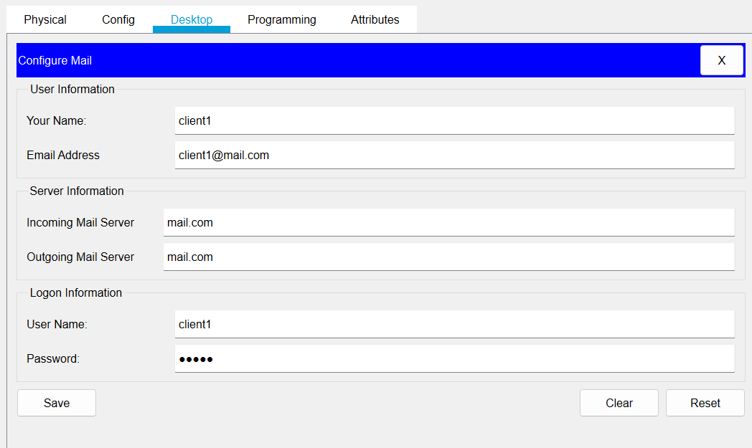

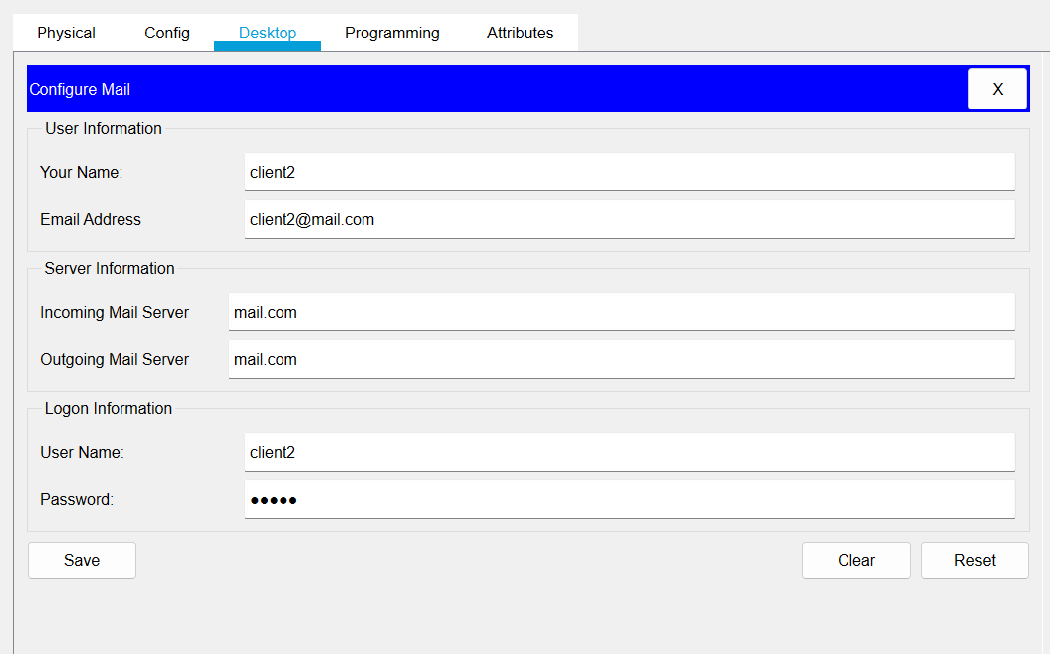

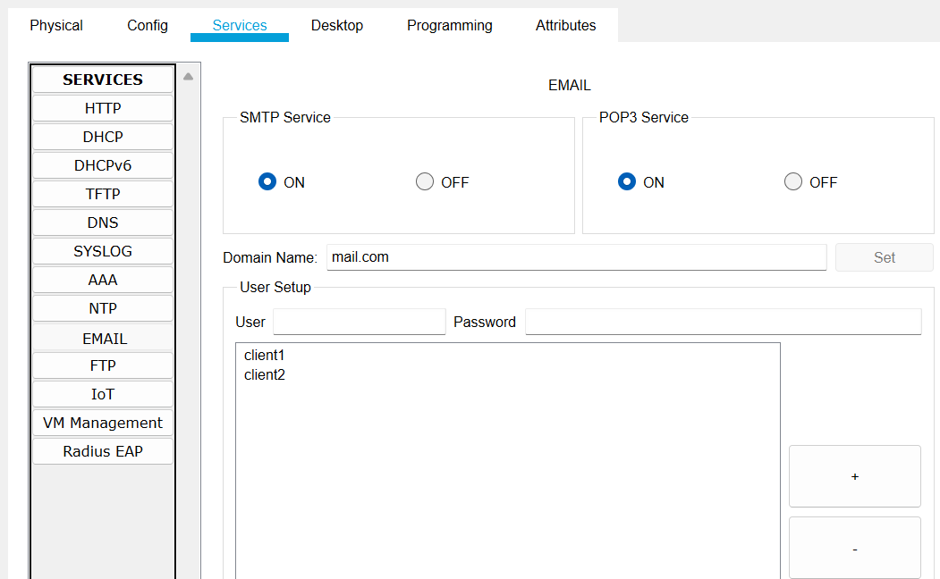

Step 4: Configure the DNS server.

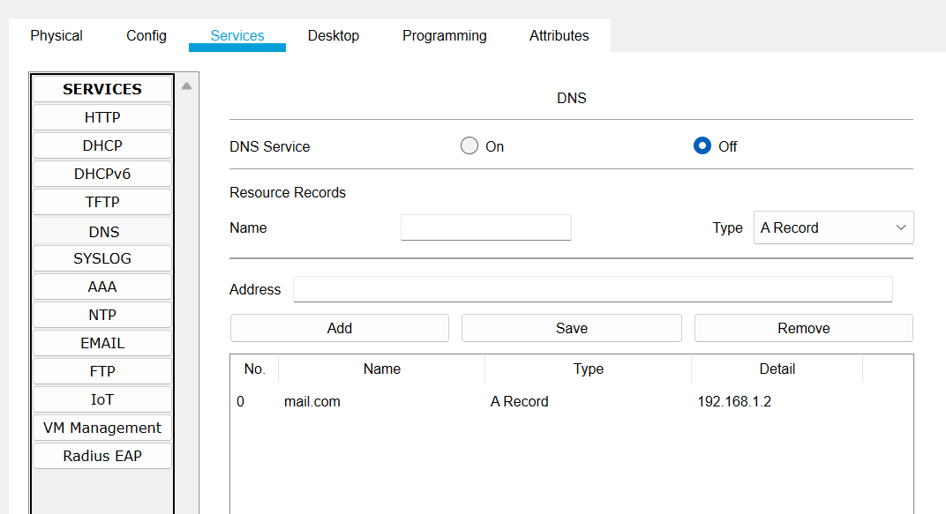

Step 5: Testing the email service.

We will to PC0 email client, compose an email and send it to PC1 email address(client2@mail.com).

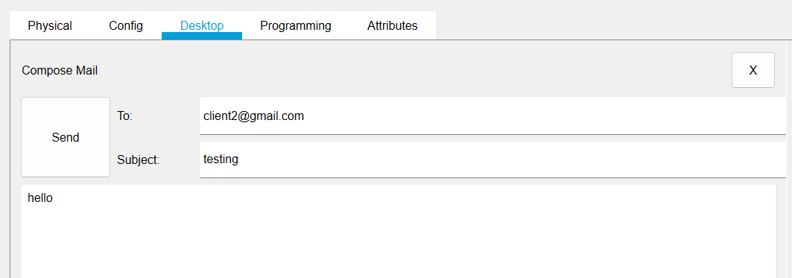

And then we will check whether the email from PC0 is received on PC1. On the email client of PC1.

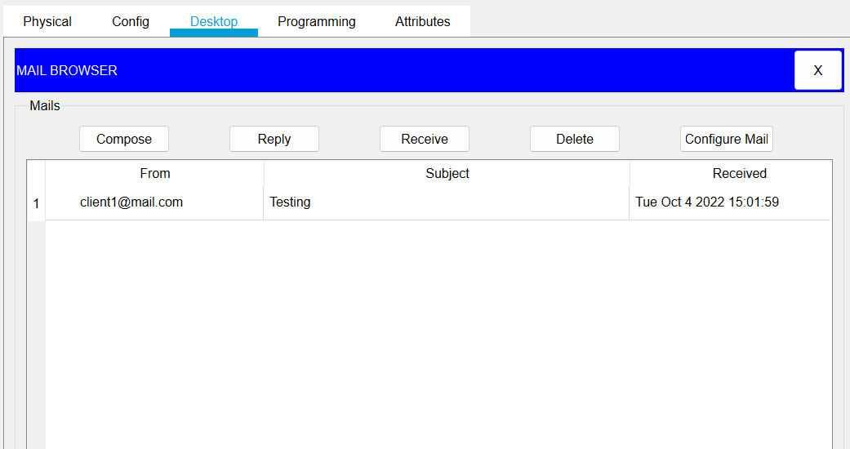

And we will send reply and check weather reply is received from PC1 to PC0.

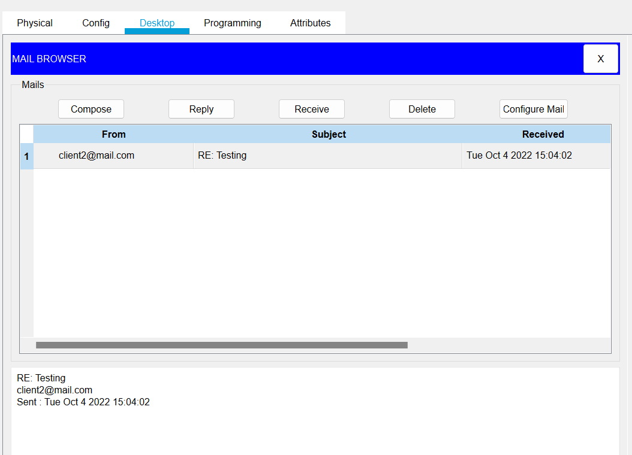

Task 2: Configure an FTP server in Packet Tracer

Step 1: Build a network topology:

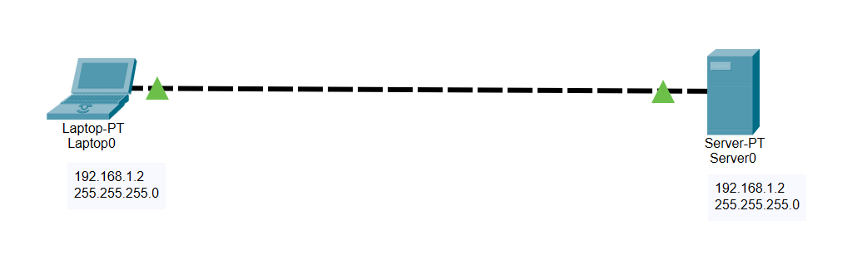

Step 2: Configure static IP addresses on the Laptop and the server.

Laptop: IP address: 192.168.1.1 Subnet Mask: 255.255.255.0

Server: IP address: 192.168.1.2 Subnet Mask: 255.255.255.0

Step 3: try using an FTP client built in the Laptop to send files to an FTP server configured in the Server.

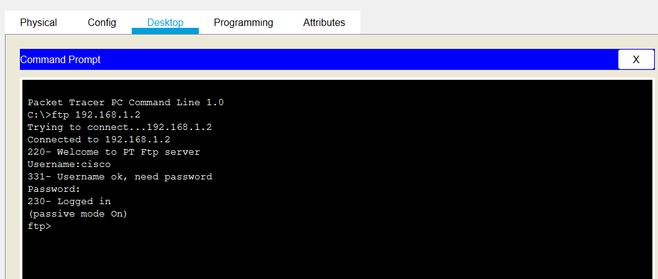

Step 4: Create a file in the Laptop then upload it to the server using FTP.

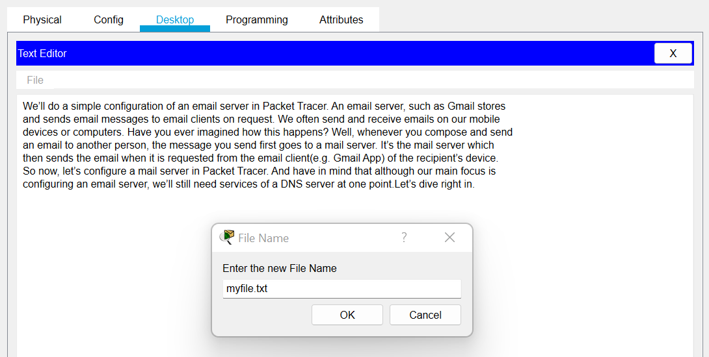

Now upload the file from the Laptop to the server using FTP.

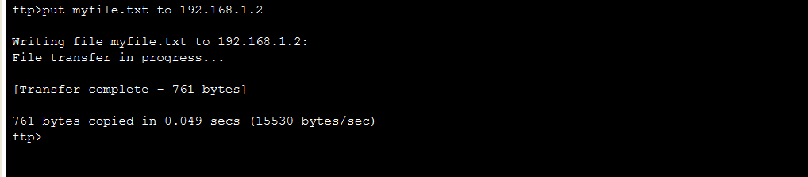

Step 5: Go to the Server FTP directory to verify if the file sent has been received

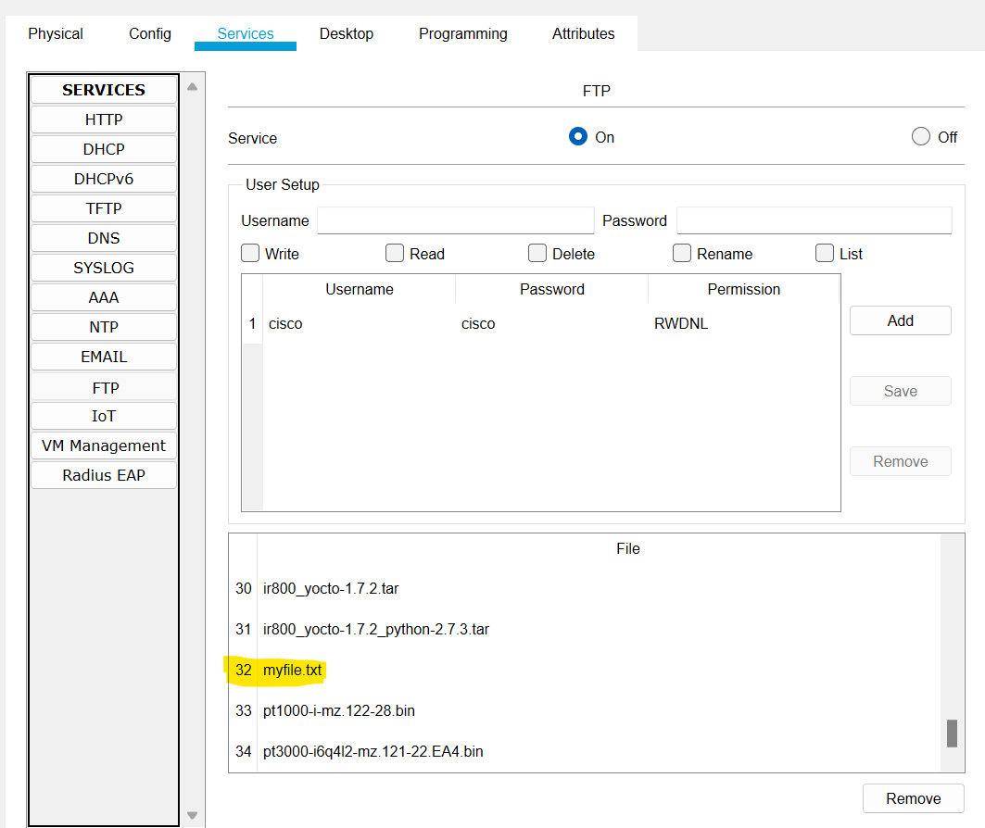

Task 3: **Create and Upload html file to HTTP server directory Using FTP**

We will use the same network topology as we used in our earlier task and will assign same static IP address and subnet mask to ftp server and our laptop.

We will write **ftp** in our CLI and give username and password. And then we will write **cd /http** and then we will write **put <filename> to <server IP>.**

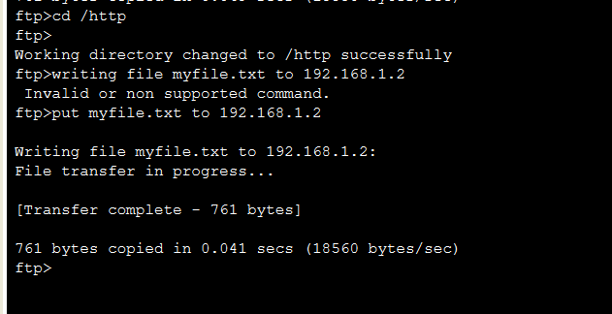

And then we will check up in the **HTTP** directory in the server and verify that the file uploaded from the Laptop.

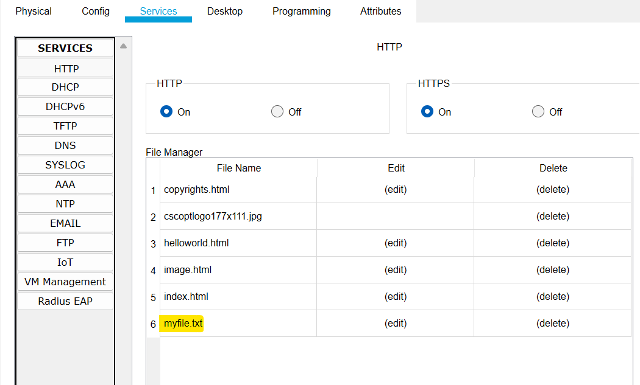

Another example for http file is we have a file for flex login page and we will upload it on http using ftp and then we will see from web browser if its working.

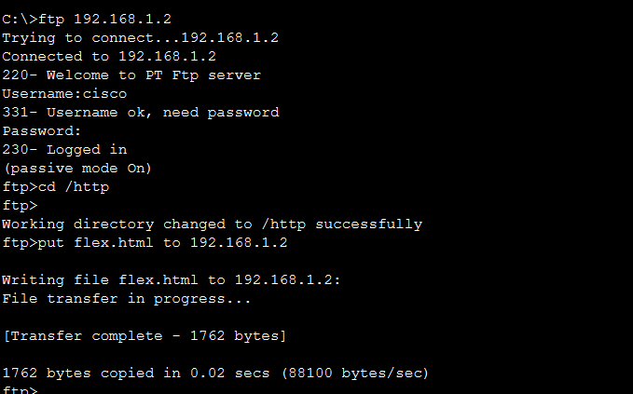

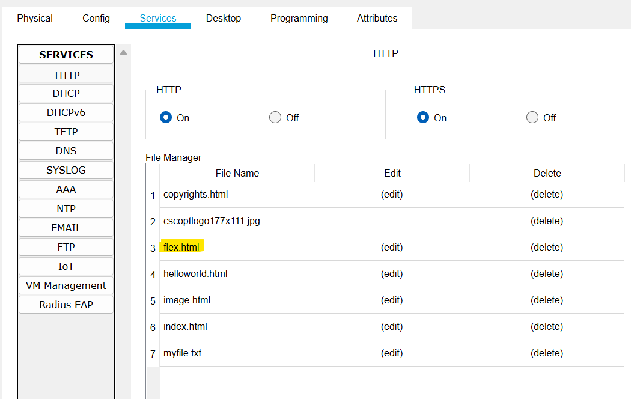

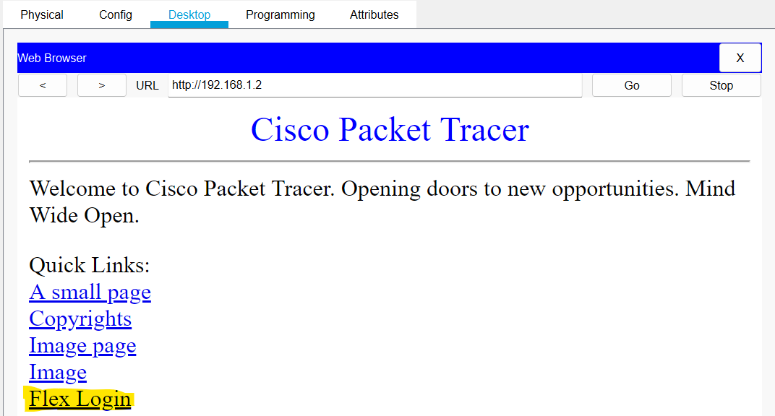

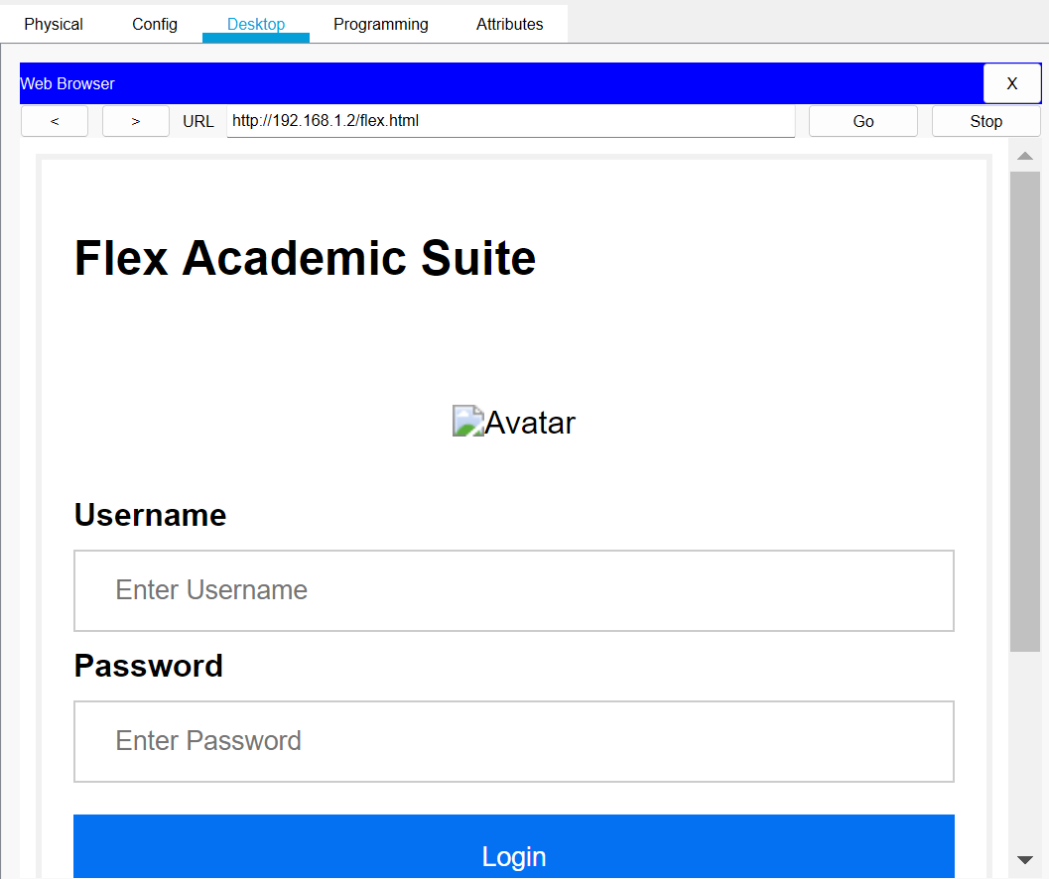

Task 4: Configure Mail server, Ftp Server, DHCP Server, DNS Server and web Server in a single topology, use router and switch.

Step1: build the network topology.

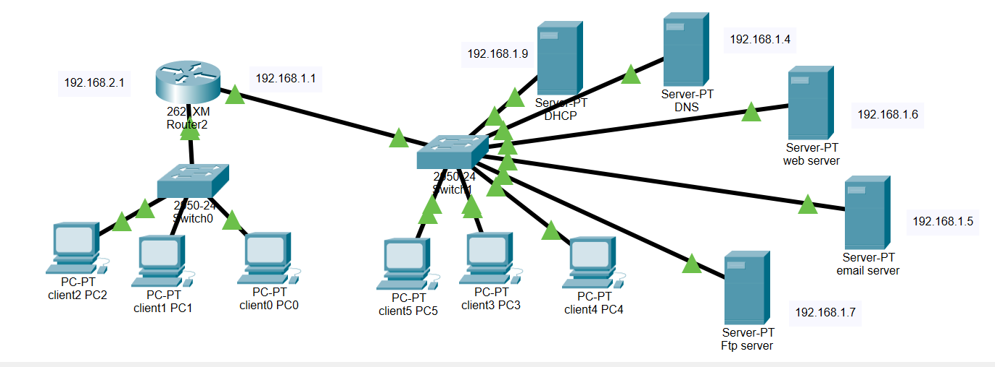

Step 2: Configure IP addresses on the PCs, router, DNS Server, DHCP server, Web server, ftp server and the Mail Server.

• Mail Server IP address: 192.168.1.5

• DNS server IP address: 192.168.1.2

• DHCP server IP address: 192.168.1.9

• web server IP address: 192.168.1.6

• ftp server IP address: 192.168.1.7

• PC5 IP address: 192.168.1.3

• router interface fa0/0 IP address: 192.168.2.1

• router interface fa0/1 IP address: 192.168.1.1

Step 3: configure services of DHCP and make IP pool.

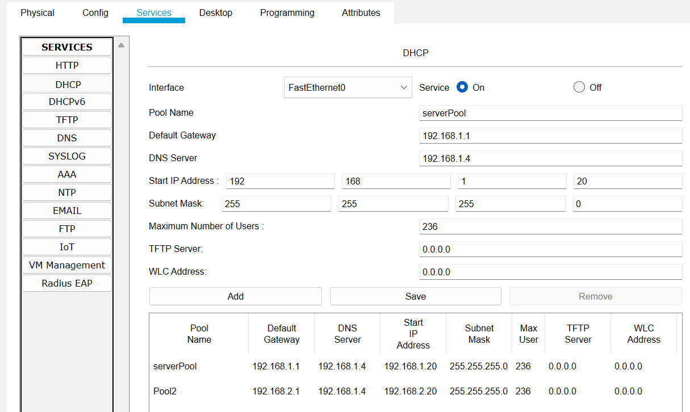

Step 4: Add Domain name in DNS server for other servers.

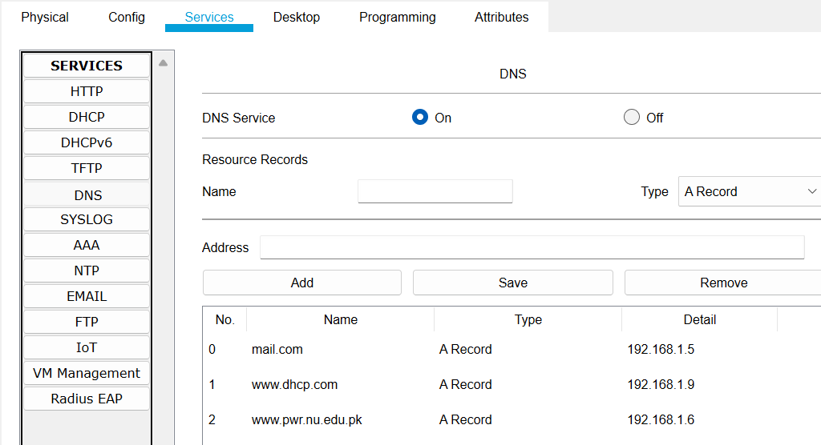

Step 5: Configure mail clients on the PCs.

PC(0)

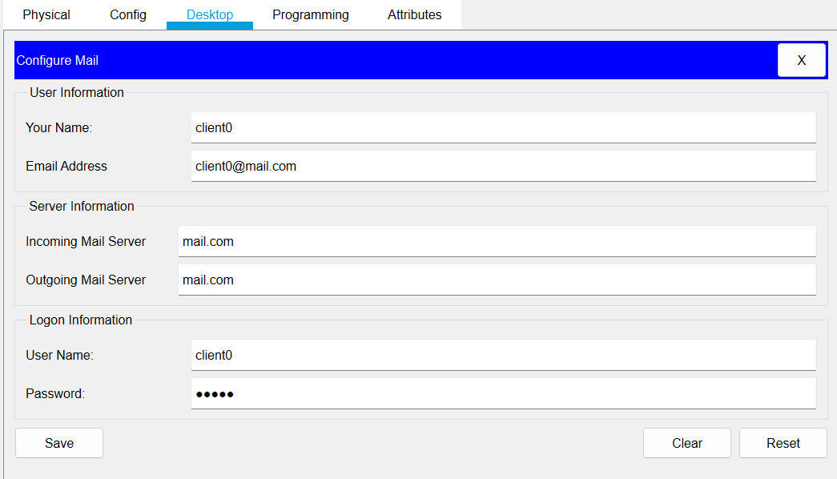

PC(1)

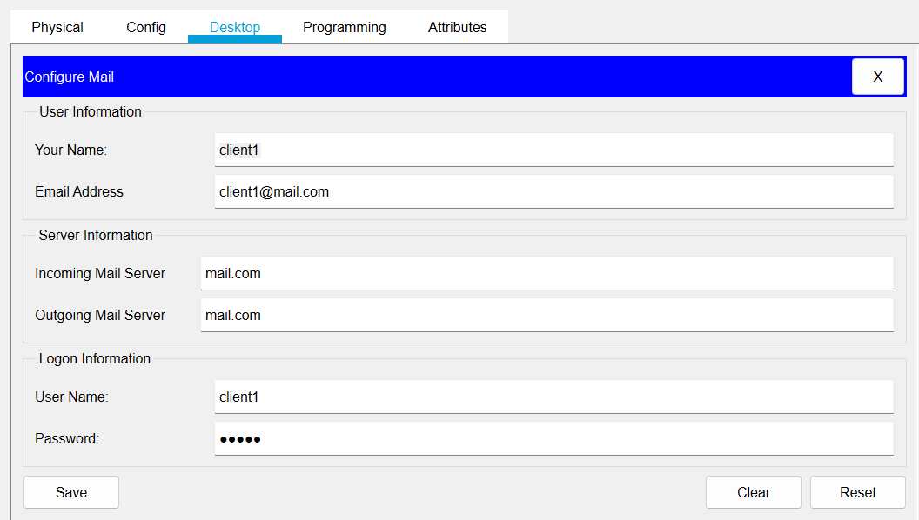

PC(2)

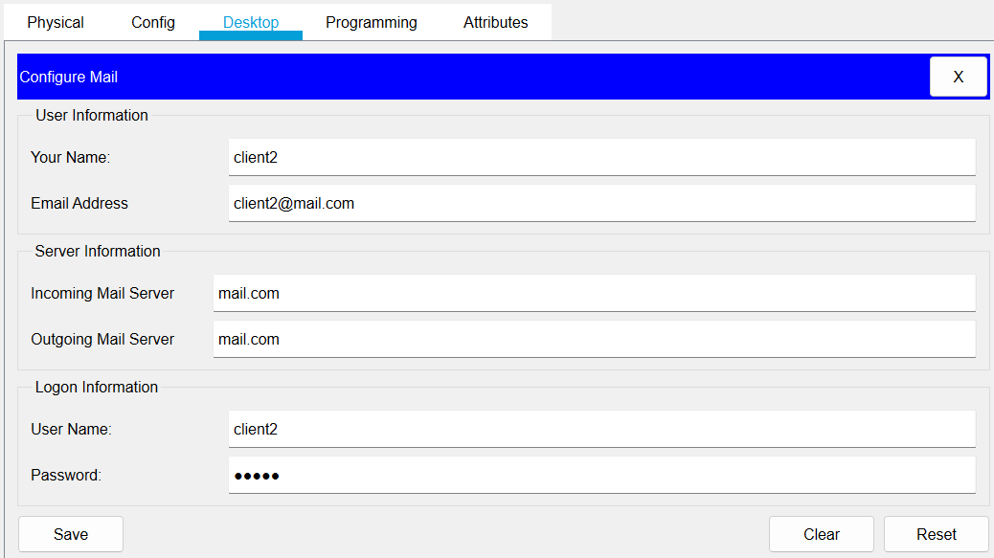

PC(3)

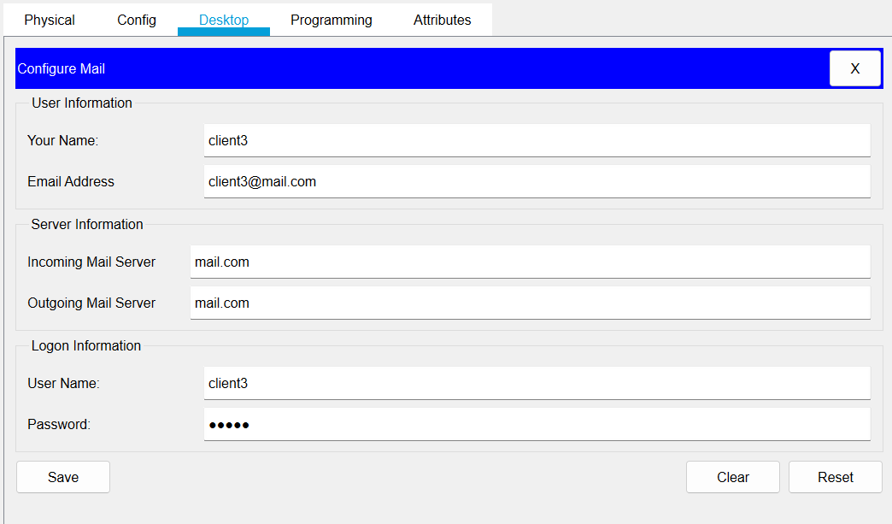

PC(4)

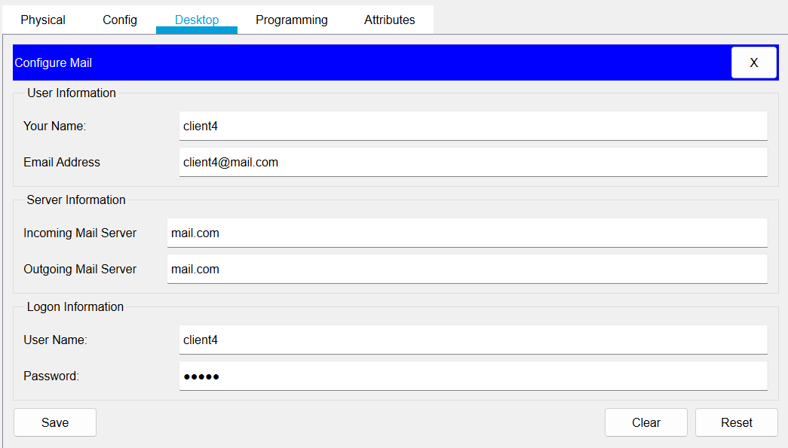

PC(5)

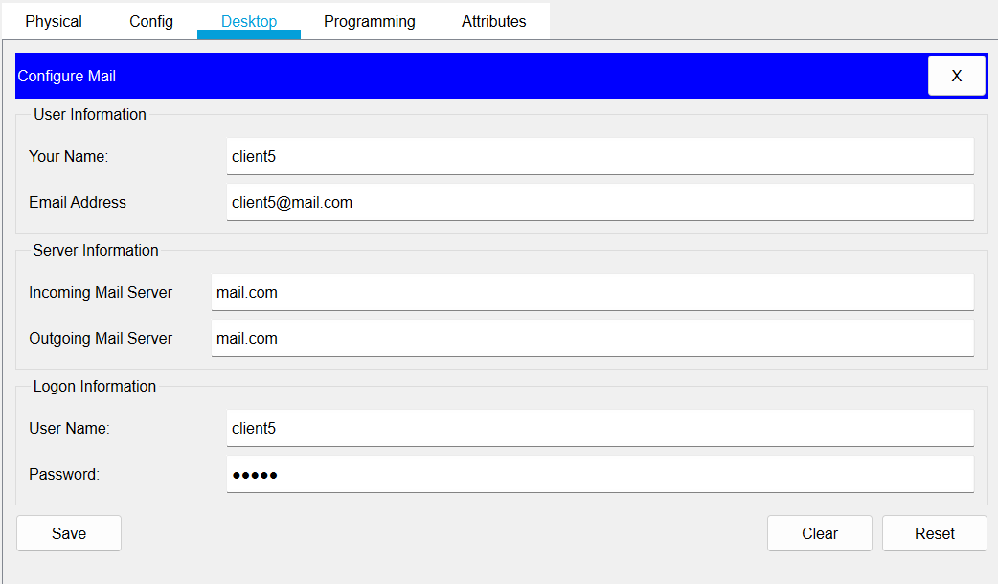

Step 6: Now we will configure the email server.

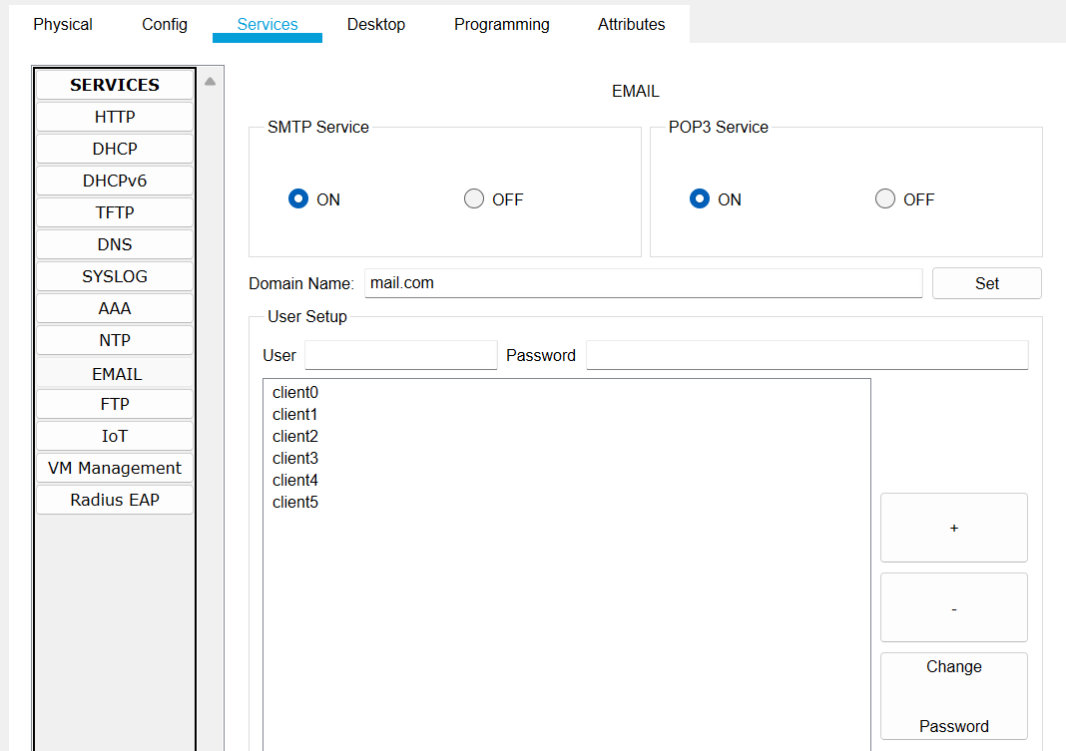

Step 7: Now we will assign Dynamic IP addresses to PCs

PC(0)

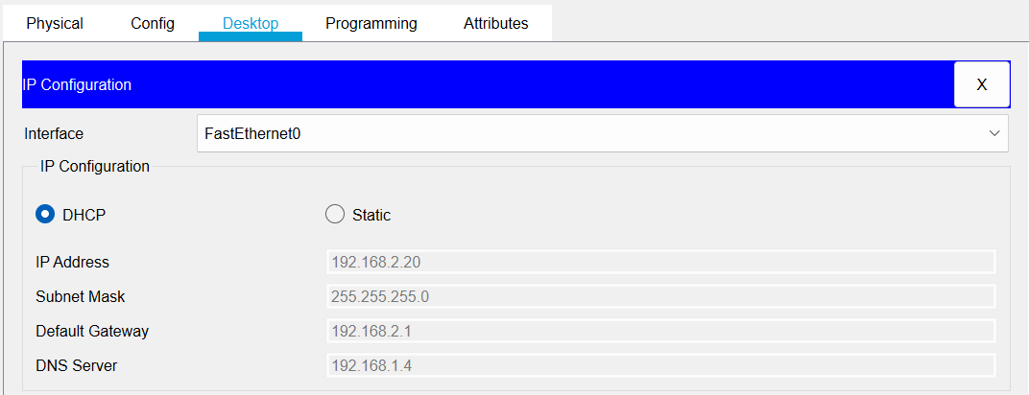

PC(1)

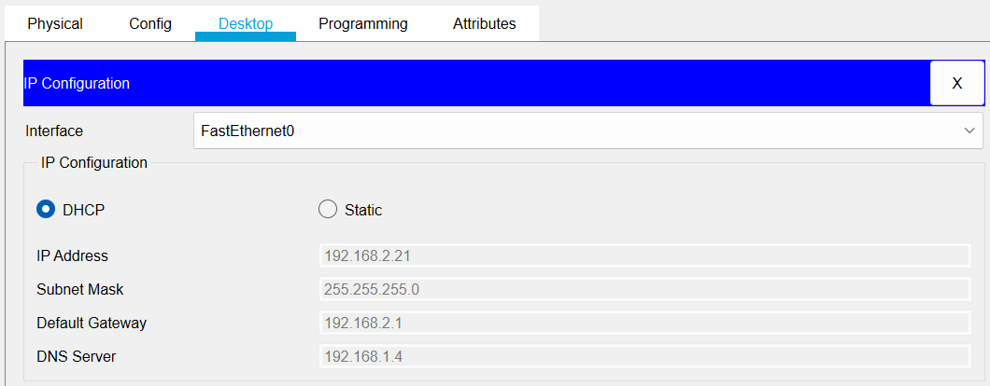

PC(2)

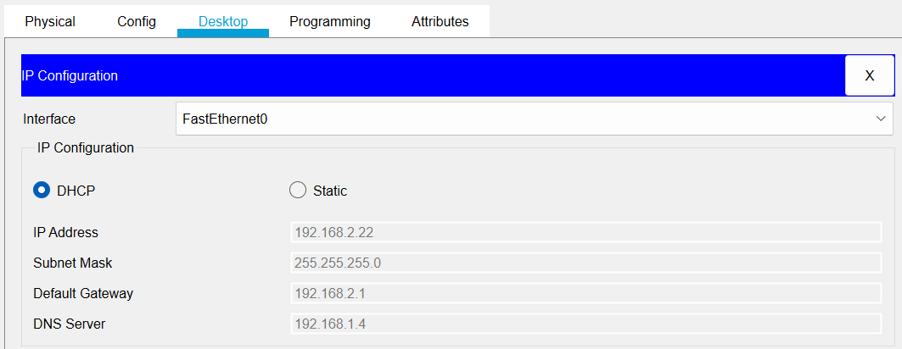

PC(3)

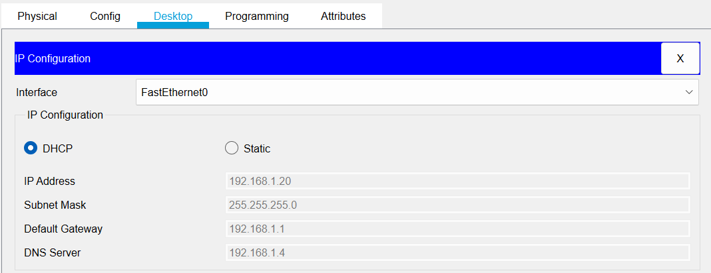

PC(4)

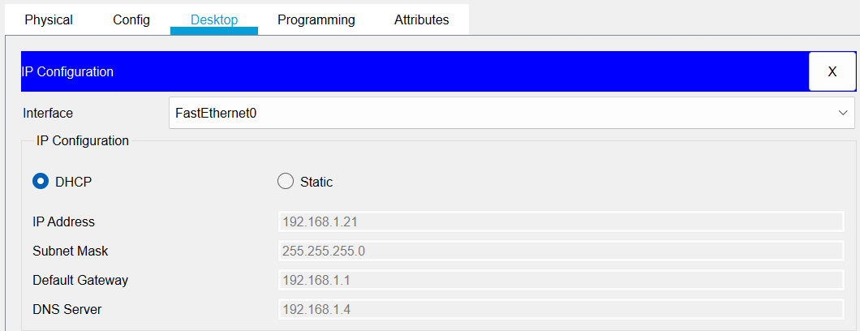

PC(5)

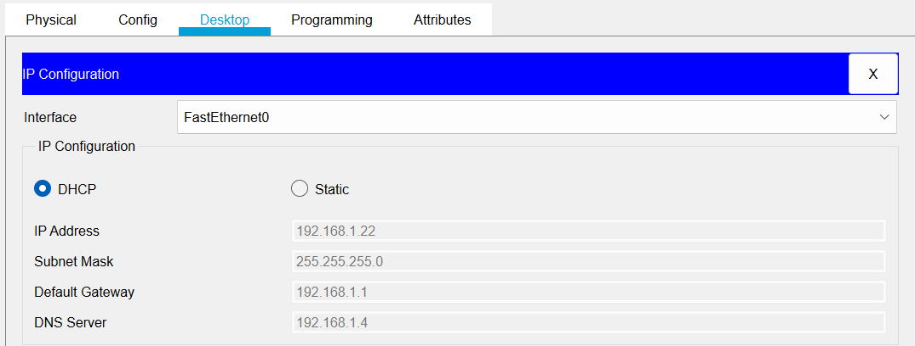

Step 8: we will check DNS server by searching a website on pc.

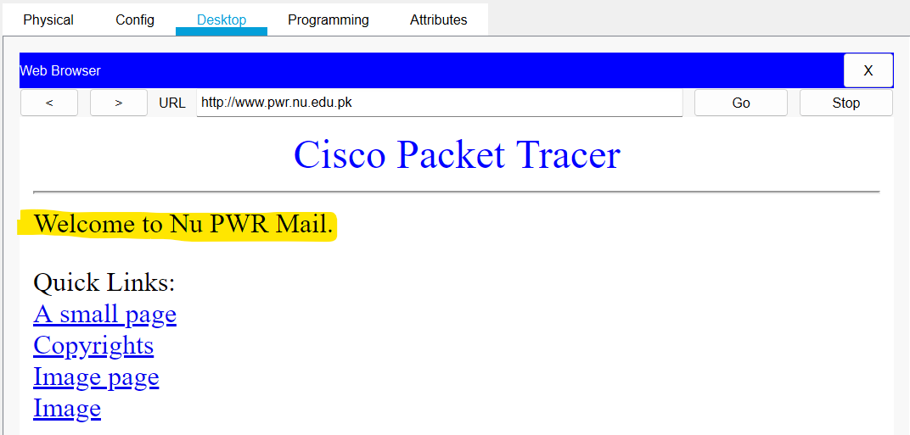

Step 9: we will check connection by pinging the pcs.

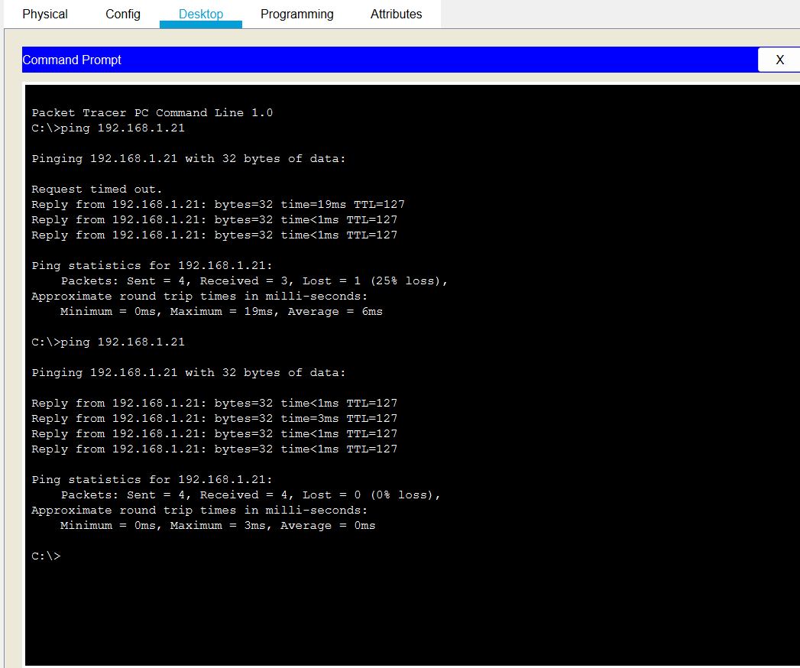

Step 10: we will check email server by sending an email from client1 to client3 and then we will send reply as well

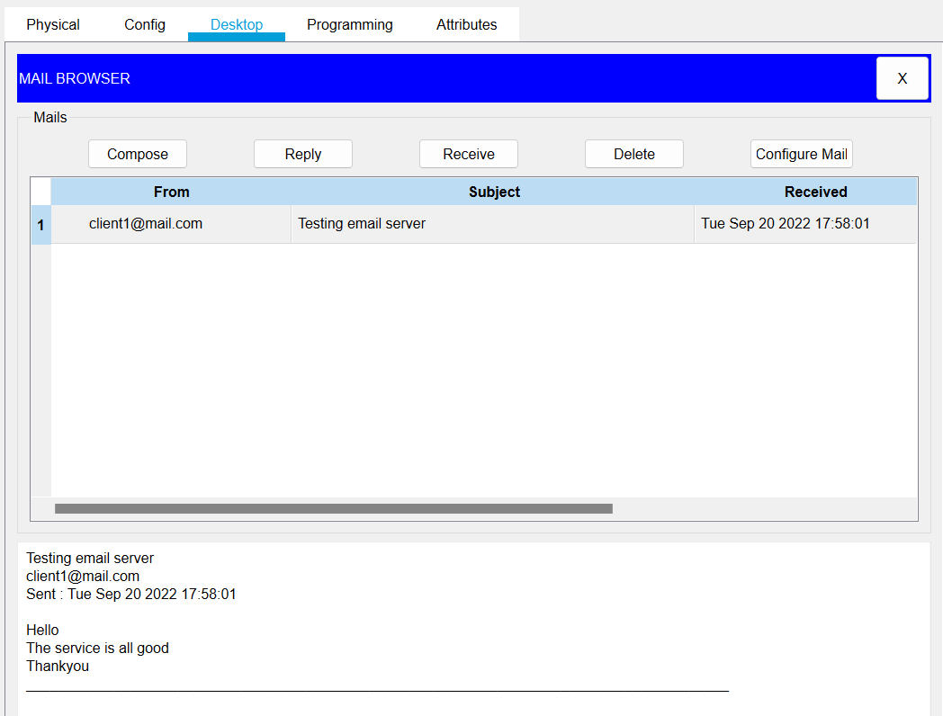

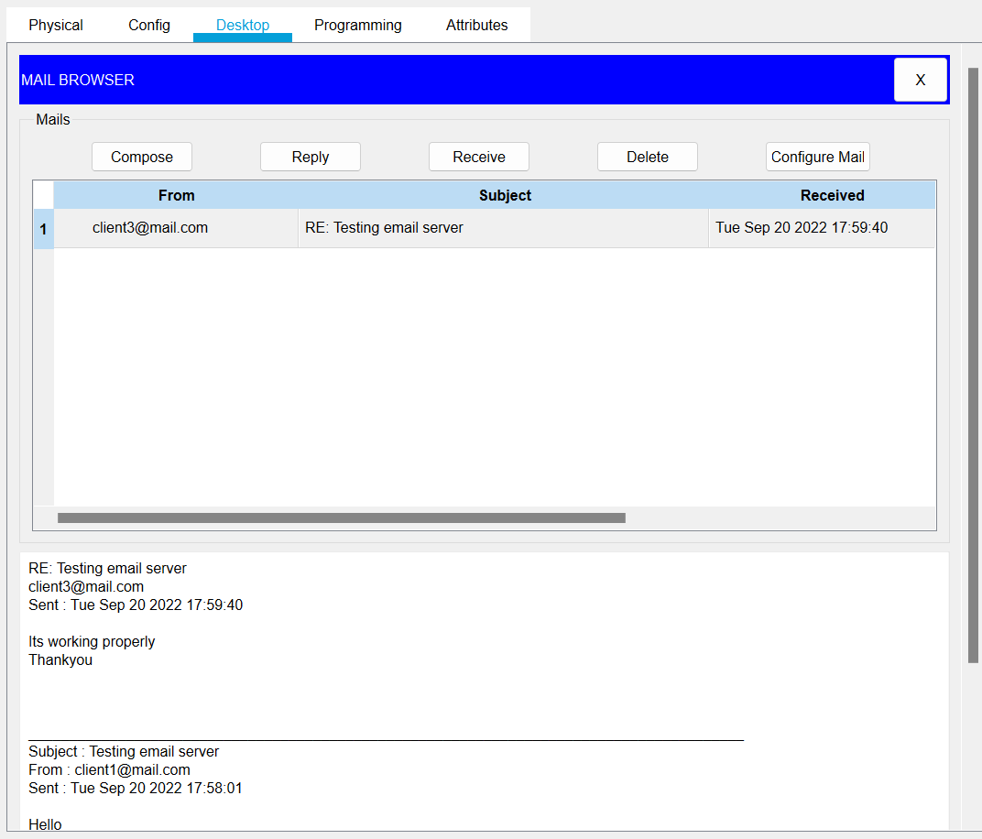

Step 11: we will use an FTP client built in the Laptop to send files to an FTP server configured in the Server.

=>First of all we will write and save a txt file.

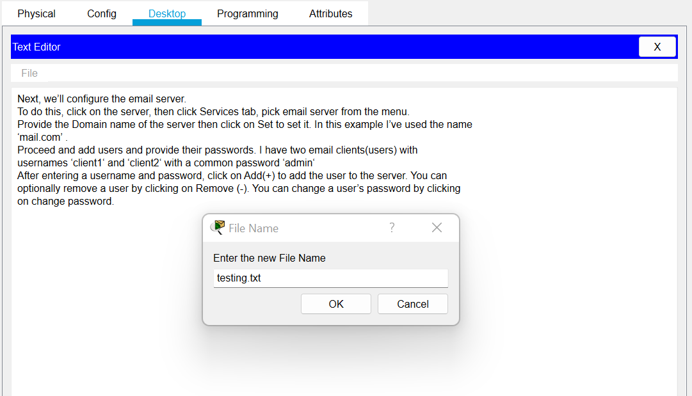

=>Then we will send the file to ftp server.

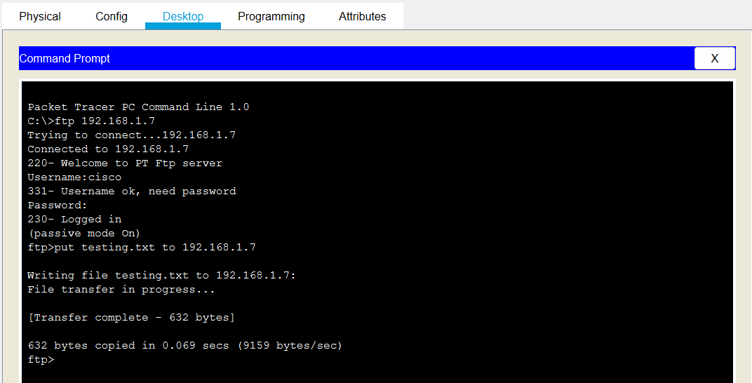

=>And then we will check the file in ftp server.

